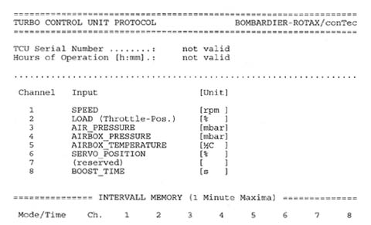

- Rotax Owner
- OFFLINE
- Administrator
- Posts: 8
- Karma: 2

Peter,
1) Here is a printout of a 4.6 TCU. The 8 columns are identified at the top of the printout.
2) The TLR software is an old DOS program that needs to communicate with a serial port on COM1 or COM2. When using a USB to Serial adapter, the newer operating system usually assign the serial port to a higher com port like COM9 to avoid communication conflict.
Here is a quick reference to set up the TLR software using a USB to serial adapter.
[TLR Software Connection]
3) Rotax has delivered the 914 with staggered needle positions for some time now. Since the airflow coming into the airbox from the turbo charger comes in from the 1/3 side of the airbox, the 2/4 carburetor will get slightly more "ram" air pressure than the 1/3 carburetor. To compensate for this, the needle is set richer on the 2/4 carb. Some engines like this staggered setup, some engine run better with the needles even.
Hope this helps,
Rotax Owner.
Report to moderator
Quick Reply Reply Quote

